# React

# ReactJS-HOL

# Mandatory HandsOn

Create a React Application “eventexamplesapp” to handle various events of the form elements in HTML.

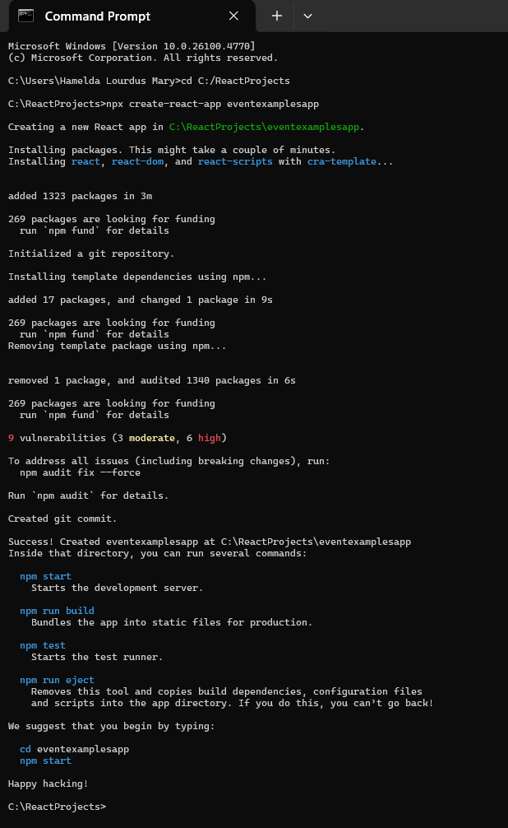

**CurrencyConvertor.js:**

import { useState } from 'react';

function CurrencyConvertor() {

    const [amountInINR, setAmountInINR] = useState('');

    const [amountInEuro, setAmountInEuro] = useState('');

    const handleSubmit = (e) => {

        e.preventDefault();

        const euroRate = 99.64;

        const convertedAmount = (parseFloat(amountInINR) / euroRate).toFixed(2);

        alert(`Converting to Euro Amount is €${convertedAmount}`);

        setAmountInEuro(convertedAmount);

    };

    return (

        <div>

            <h2 style={{ color: 'green' }}>Currency Convertor!!!</h2>

            <form onSubmit={handleSubmit}>

                <label>Amount (INR): </label>

                <input

                    type="text"

                    value={amountInINR}

                    onChange={(e) => setAmountInINR(e.target.value)}

                /><br /><br />

                <label>Currency (Euro): </label>

                <input

                    type="text"

                    value={amountInEuro}

                    readOnly

                /><br /><br />

                <button type="submit">Submit</button>

            </form>

        </div>

    );

}

export default CurrencyConvertor;

**App.js**

import { useState } from 'react';

import './App.css';

import CurrencyConvertor from './CurrencyConvertor';

function App() {

  const [count, setCount] = useState(0);

  const increment = () => {

    setCount(prev => prev + 1);

    sayHello();

  };

  const decrement = () => {

    setCount(prev => prev - 1);

  };

  const sayHello = () => {

    alert("Hello! You clicked increment.");

  };

  const sayWelcome = (message) => {

    alert(message);

  };

  const handleOnPress = (event) => {

    alert("I was clicked");

    console.log(event);

  };

  return (

    <div className="App">

      <h2>Count: {count}</h2>

      <button onClick={increment}>Increment</button>

      <button onClick={decrement}>Decrement</button>

      <br /><br />

      <button onClick={() => sayWelcome("Welcome")}>Say Welcome</button>

      <br /><br />

      <button onClick={handleOnPress}>Click on me</button>

      <br /><br />

      <CurrencyConvertor />

    </div>

  );

}

export default App;

**App.css**

.App {

  margin-top: 30px;

}

button {

  margin: 5px;

}

**Output:**

npm start

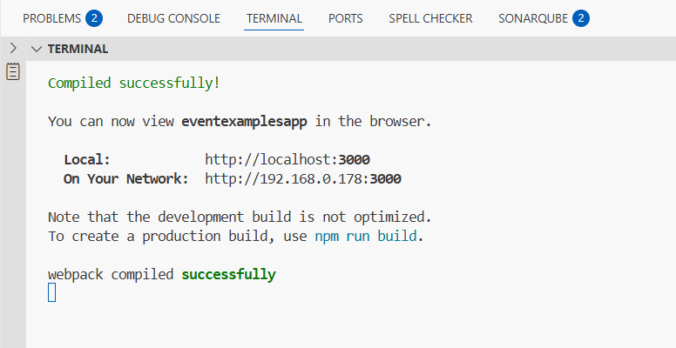

1. Create “Increment” button to increase the value of the counter and “Decrement” button to decrease the value of the counter. The “Increase” button should invoke multiple methods.
   1. **To increment the value**

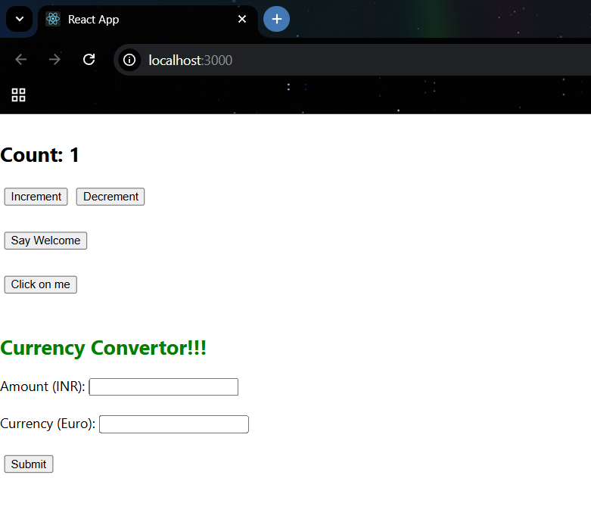

* 1. **Say Hello followed by a static message.**

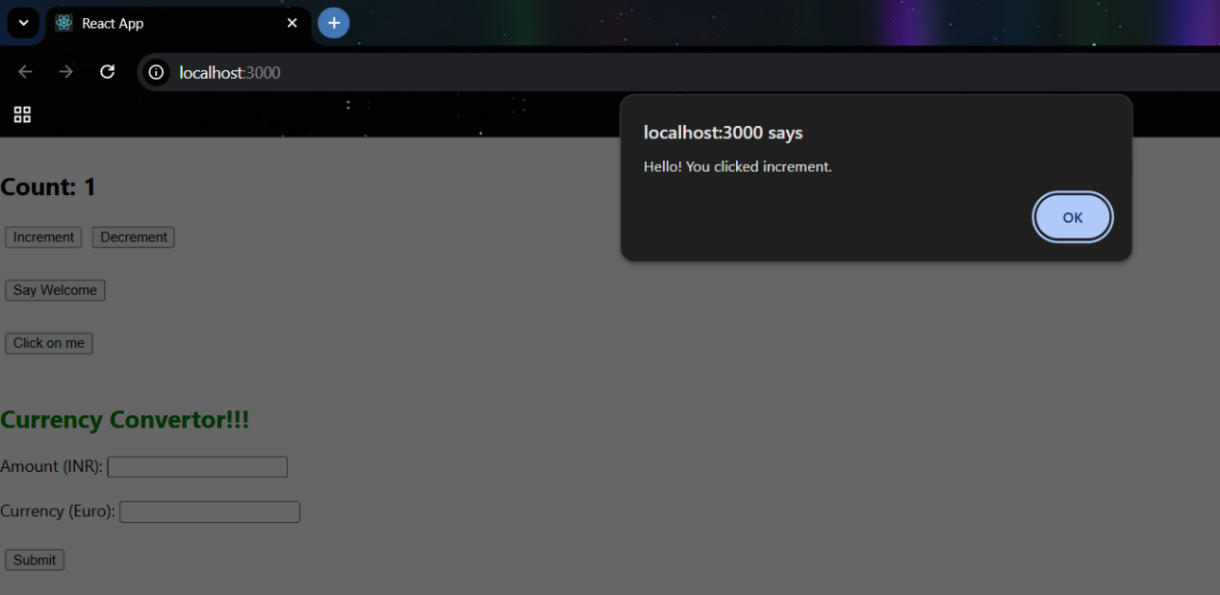

1. Create a button “Say Welcome” which invokes the function which takes “welcome” as an argument.

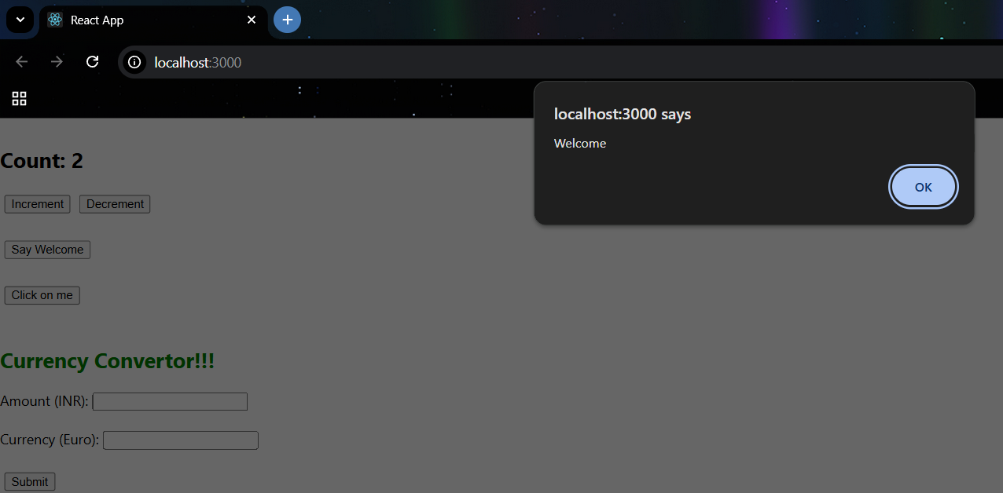

1. Create a button which invokes synthetic event “OnPress” which display “I was clicked”

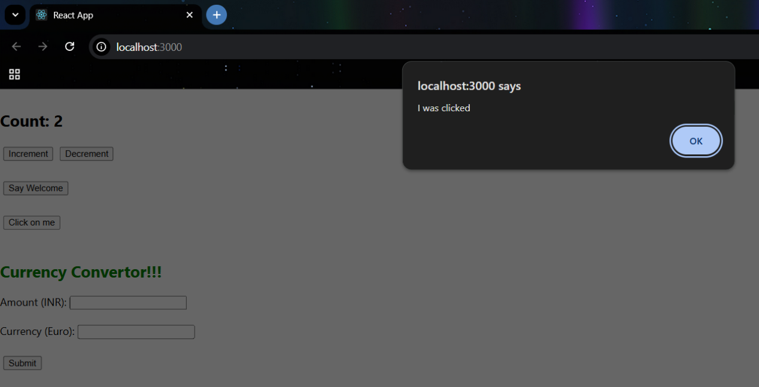

1. Create a “CurrencyConvertor” component which will convert the Indian Rupees to Euro when the Convert button is clicked.

Handle the Click event of the button to invoke the handleSubmit event and handle the conversion of the euro to rupees.

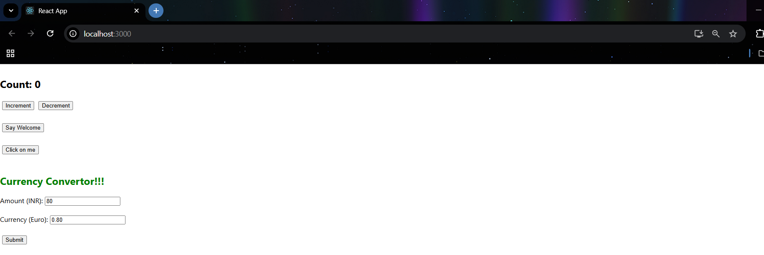

Example : 1 rs =0.010 euro

